Progress report of the semester-end project on Face Recognition system.
Introduction
Facial recognition is a bio metric software application capable of uniquely identifying or verifying a person by comparing and analyzing patterns based on the person's facial contours. Facial recognition is mostly used for security purposes, though there is increasing interest in other areas of use. In fact, facial recognition technology has received significant attention as it has potential for a wide range of application related to law enforcement as well as other enterprises.

Modular Approach
- Face Recognition
The module face_recognition is used to recognize and manipulate faces from Python or from the command line with the world’s simplest face recognition library. Built using dlib’s state-of-the-art face recognition built with deep learning. The model has an accuracy of 99.38% on the labeled faces in the wild benchmark. This also provides a simple face_recognition command line tool that lets you do face recognition on a folder of images from the command line.

- OpenCV
OpenCV is the most popular library for computer vision. Originally written in C/C++, it now provides bindings for Python. OpenCV uses machine learning algorithms to search for faces within a picture. Because faces are so complicated, there isn’t one simple test that will tell you if it found a face or not. Instead, there are thousands of small patterns and features that must be matched. The algorithms break the task of identifying the face into thousands of smaller, bite-sized tasks, each of which is easy to solve. These tasks are also called classifiers. For something like a face, you might have 6,000 or more classifiers, all of which must match for a face to be detected (within error limits, of course).
Source Code:
import face_recognition
import cv2

#def Main():
video_capture = cv2.VideoCapture(0)

# Load a sample picture and learn how to recognize it.

omega_image=face_recognition.load_image_file("omega1.jpg")
niraj_image=face_recognition.load_image_file("Niraj.jpg")
vishal_image=face_recognition.load_image_file("vishal.jpg")
nishu_image=face_recognition.load_image_file("nishu.jpg")
sabibek_image=face_recognition.load_image_file("sabibek.jpg")

# Get the face encodings for each face in each image file
# Since there could be more than one face in each image, it returns a list of encodings.

omega_image_encoding=face_recognition.face_encodings(omega_image)[0]
niraj_image_encoding=face_recognition.face_encodings(niraj_image)[0]
vishal_image_encoding=face_recognition.face_encodings(vishal_image)[0]
nishu_image_encoding=face_recognition.face_encodings(nishu_image)[0]
sabibek_image_encoding=face_recognition.face_encodings(sabibek_image)[0]
# Create arrays of known face encodings and their names
known_face_encodings = [omega_image_encoding,niraj_image_encoding,vishal_image_encoding,nishu_image_encoding,sabibek_image_encoding]

known_face_names =["Omega","Niraj","Vishal","Butki","Sabibek"]
#print(type(known_face_names))
# Initialize some variables
face_locations = []
face_encodings = []
face_names = []
process_this_frame = True

while True:
# Grab a single frame of video
ret, frame = video_capture.read()

# Resize frame of video to 1/4 size for faster face recognition processing
small_frame = cv2.resize(frame, (0, 0), fx=0.25, fy=0.25)

# Convert the image from BGR color (which OpenCV uses) to RGB color (which face_recognition uses)
rgb_small_frame = small_frame[:, :, ::-1]

# Only process every other frame of video to save time
if process_this_frame:
# Find all the faces and face encodings in the current frame of video
face_locations = face_recognition.face_locations(rgb_small_frame)
face_encodings = face_recognition.face_encodings(rgb_small_frame, face_locations)

face_names = []
for face_encoding in face_encodings:
# See if the face is a match for the known face(s)
matches = face_recognition.compare_faces(known_face_encodings, face_encoding)
name = "Unknown"

# If a match was found in known_face_encodings, just use the first one.
if True in matches:
first_match_index = matches.index(True)
name = known_face_names[first_match_index]

face_names.append(name)

process_this_frame = not process_this_frame

# Display the results
for (top, right, bottom, left), name in zip(face_locations, face_names):
# Scale back up face locations since the frame we detected in was scaled to 1/4 size
top *= 4
right *= 4
bottom *= 4
left *= 4

# Draw a box around the face
cv2.rectangle(frame, (left, top), (right, bottom), (0, 0, 255), 2)

# Draw a label with a name below the face
cv2.rectangle(frame, (left, bottom - 35), (right, bottom), (0, 0, 255), cv2.FILLED)
font = cv2.FONT_HERSHEY_DUPLEX
cv2.putText(frame, name, (left + 6, bottom - 6), font, 1.0, (255, 255, 255), 1)

# Display the resulting image
cv2.imshow('Video', frame)

# Hit 'q' on the keyboard to quit!
if cv2.waitKey(1) & 0xFF == ord('q'):
break
#wb.save("Excel.xls")
# Release handle to the webcam
video_capture.release()
cv2.destroyAllWindows()

#if __name__=="__main__":
# Main()

Screenshot of the project :
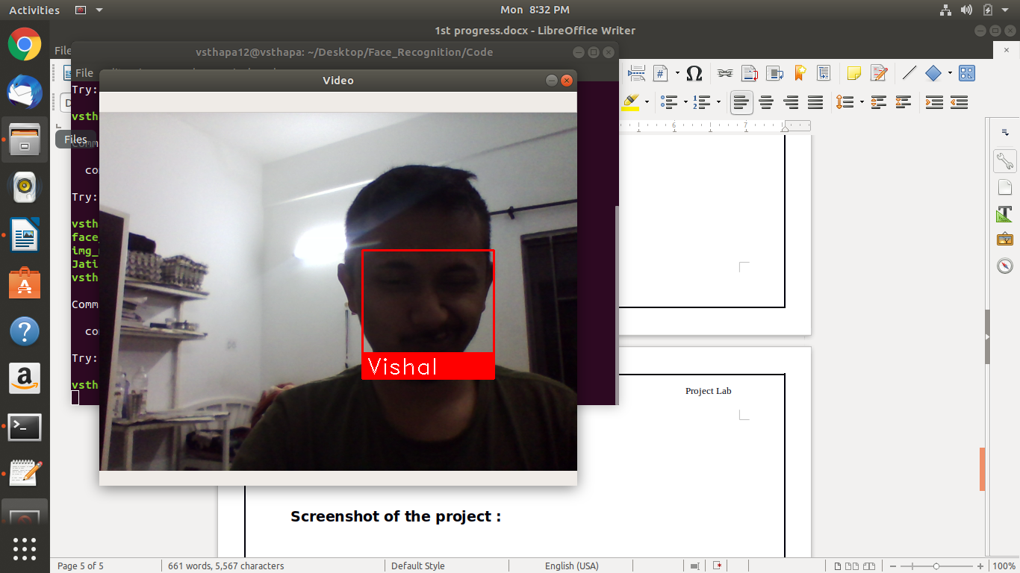

Fig:Face Detection for known people

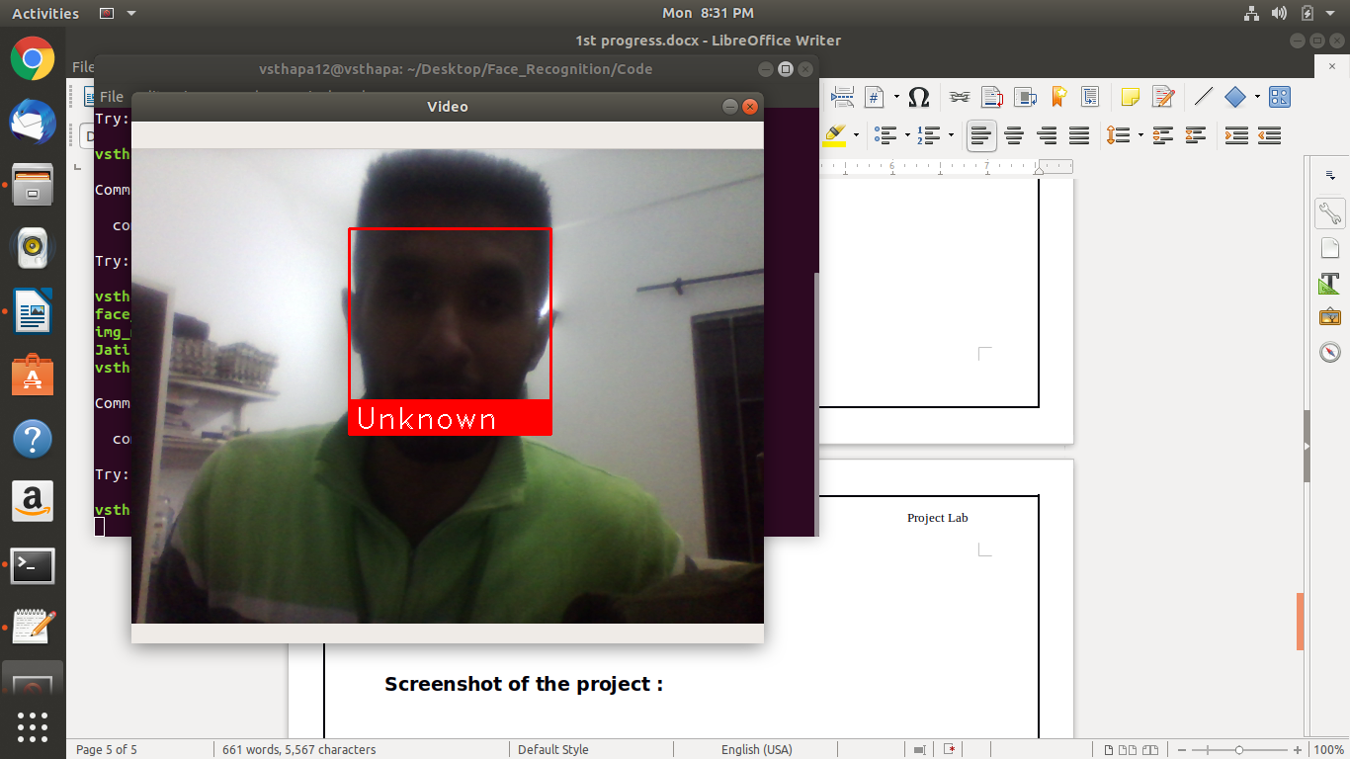
Fig: Face Detection for Unknown People

